Abstract Title

Fullname¹, Fullname², Fullname³, etc.

¹XYZ University of Warsaw, Warsaw, Poland, email@uw.edu.pl; ²XYZ Consulting Firm, Geneva, Swiss, email@xyz.com;³XYZ Corp., San Francisco, CA,USA, email@xyz.org.

ABSTRACT
The abstract should be written in English, in MS Word format, and fit on a single A4 sheet (210 mm x 297 mm or 8.27 in x 11.69 in) with 25 mm margins all around. Use Times New Roman 13 in bold for the Abstract Title, Times New Roman 12 for the names of authors, Times New Roman 10 italic for authors affiliations, and Times New Roman 11 for the text body, the line spacing of which should be 1.5. Enter either “Oral” or “Poster” after “presentation type:” in the footer…
The abstract can include one image adjusted for black and white printing and the image should not exceed 25% of the abstract’s volume.

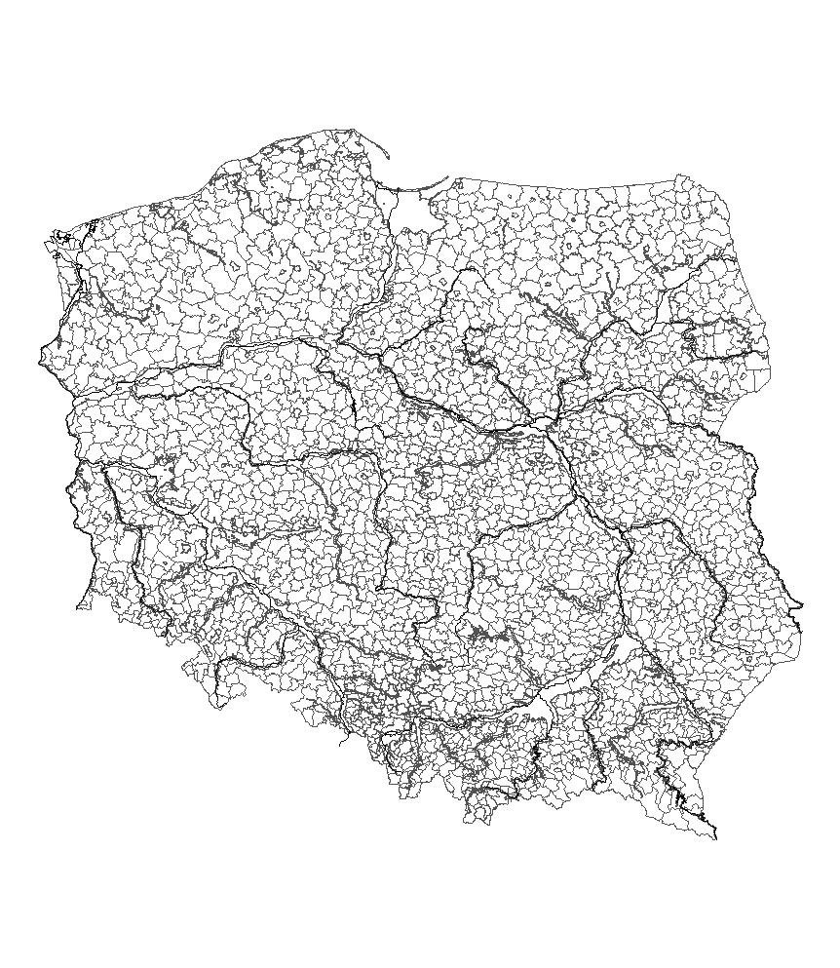

The abstract has to end here.

